
PE/Sport Premium Report
2023 – 2024



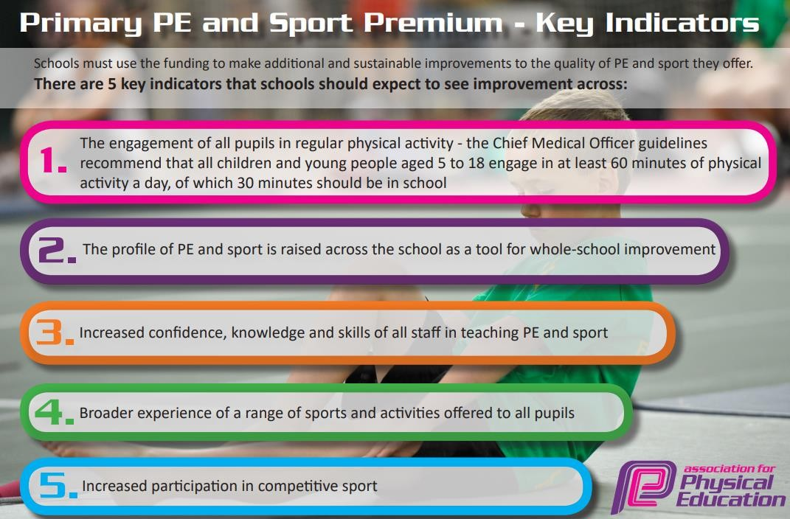

Meeting national curriculum requirements for swimming and water safety.
What percentage of your current Year 5 cohort swim competently, confidently and proficiently over a distance of at least 25 metres? | 61%
What percentage of your current Year 5 cohort use a range of strokes effectively [for example, front crawl, backstroke and breaststroke]? | 48%
What percentage of your current Year 5 cohort perform safe self-rescue in different water-based situations? | 15%
Schools can choose to use the Primary PE and Sport Premium to provide additional provision for swimming but this must be for activity over and above the national curriculum requirements. Have you used it in this way? | No

Key achievements to date until July 2023: | Areas for further improvement and baseline evidence of need:
- Staff have gained confidence in teaching PE through shadowing sports coaches.  - There are a range of activities available for pupils to engage in at lunchtimes.  - The new equipment purchased last academic year is supplementing PE lessons, lunchtime provision and extra-curricular clubs well.  - Football team formed and games set up with local schools.  - Extra-curricular clubs are attended well! | - New PE curriculum needs implementing and further embedding. All children now take part in 2 PE lessons per week.  - Staff need training on the assessment of PE skills.  - Revisit and review staff training to ensure staff feel confident in teaching and use the sports coach to enable this.  - Lunchtime provision to include further sporting opportunities.  - We need to secure swimming outcomes for our year 5 pupils.

Action Plan and Budget Tracking
Academic Year: 2023- 2024 |  | Total fund allocated: £19,570 |  |  | Reviewed:
Intent | Implementation |  | Cost | Impact | Next steps:
Pupils engage in regular physical activity (30 minutes of physical activity a day in school).  - % of pupils achieving ARE in each area PE to increase from last year in every year group.  - % of lunchtime incidents decreases due the engagement in lunchtime programme. | Learning mentor role extended to that of a sports coach during playtimes and lunchtimes. Role includes coordinating the extracurricular programme at lunchtimes.  Continue employment of sports coach to assist with the running of extracurricular lunchtime clubs.  - Project Sport  Employ sports coach to deliver additional PE session with specific year groups- Project Sport,  Purchase new high quality equipment to reinvigorate playtime provision.  Pupils to engage with:  - 2 PE session per week  - 45 minutes of play time each day where physical activity and games are encouraged and facilitated by  Coaches.  - Playground equipment to support skills at break time |  | Sports equipment £2600  Vehicle Hire- £700  Project Sport- £5000  Proportion of Learning Mentors salary to support the development of sports in schools- £7635  £235

Swimming -  Pupils leave Y6 being able to:  - Perform safe self-rescue in different water based situations  - Swim competently, confidently and proficiently over a distance of at least 25 metres  - Use a range of strokes effectively, for example, front crawl, backstroke and breaststroke. | - Swimming: Y4 - 1 hour session per week for 19 weeks, starting 20th February. | Funded from main school budget.
The profile of PE and sport is being raised across the school as a tool for whole school improvement. | ‘Get Set 4 PE’ assessment framework further embedded to allow clear understanding of ARE in each area of PE, resulting in accurate assessment and precision planning to narrow gaps in ability.  Further develop provision/resources for each of the new PE units and use sports coach modelling to support teachers in their teaching of PE.  Monitor the effectiveness of teaching and learning in PE in light of the above  The profile of sports and PE through a sports and enrichment week. | £1.500 Get Set 4 PE  £500 training costs for Get set 4 PE.  £1,000 enrichment week  £400 hire of Spen Track
Increased confidence, knowledge and skills of all staff in teaching PE and sport. | PE to be clearly mapped out across year groups.  Develop leadership of PE by planning in coaching sessions for PE Leader and Learning Mentor from the Curriculum Lead regarding the effectiveness of PE throughout school.  CPD (coaching/mentoring support) from coach (Project Sports) who will use Get set 4 PE planning to model teaching, team- teach and offer support/feedback to develop teacher  confidence and expertise. | Costed above
Total spend: | £19,570

